Elton, Gruber, Brown, and Goetzmann
Modern Portfolio Theory and Investment Analysis, 9th Edition
Solutions to Text Problems: Chapter 26

Chapter 25: Problem 1

Using standard deviation as the measure for variability, the reward-to-variability ratio for a fund is the fund’s excess return (average return over the riskless rate) divided by the standard deviation of return, i.e., the fund’s Sharpe ratio. E.g., for fund A we have:

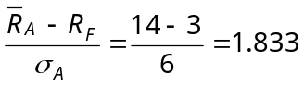

See the table in the answers to Problem 5 for the remaining funds’ Sharpe ratios.

Chapter 25: Problem 2

The Treynor ratio is similar to the Sharpe ratio, except the fund’s beta is used in the denominator instead of the standard deviation. E.g., for fund A we have:

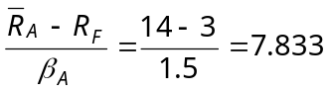

See the table in the answers to Problem 5 for the remaining funds’ Treynor ratios.

Chapter 25: Problem 3

A fund’s differential return, using standard deviation as the measure of risk, is the fund’s average return minus the return on a naïve portfolio, consisting of the market portfolio and the riskless asset, with the same standard deviation of return as the fund’s. E.g., for fund A we have:

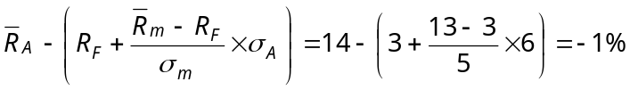

See the table in the answers to Problem 5 for the remaining funds’ differential returns based on standard deviation.

Chapter 25: Problem 4

A fund’s differential return, using beta as the measure of risk, is the fund’s average return minus the return on a naïve portfolio, consisting of the market portfolio and the riskless asset, with the same beta as the fund’s. This measure is often called “Jensen’s alpha.” E.g., for fund A we have:

See the table in the answers to Problem 5 for the remaining funds’ Jensen alphas.

Chapter 25: Problem 5

This differential return measure is the same as the one used in Problem 4, except that the riskless rate is replaced with the average return on a zero-beta asset. E.g., for fund A we have:

The answers to Problems 1 through 5 for all five funds are as follows:

Fund | Sharpe  Ratio |  |  |  |  | Treynor  Ratio |  |  |  |  |  | Differential  Return  Based On  Standard  Deviation |  |  |  |  | Differential  Return  Based On  Beta and R_{F} |  |  |  | Differential  Return  Based On  Beta and 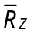
A |  | 1.833 |  |  |  |  |  | 7.333 |  |  |  |  |  | −1% |  |  |  | −4% |  |  |  | −3.5%
B |  | 2.250 |  |  |  |  |  | 18.000 |  |  |  |  |  | 1% |  |  |  | 4% |  |  |  | 3.5%
C |  | 1.625 |  |  |  |  |  | 13.000 |  |  |  |  |  | −3% |  |  |  | 3% |  |  |  | 3.0%
D |  | 1.063 |  |  |  |  |  | 14.000 |  |  |  |  |  | −5% |  |  |  | 2% |  |  |  | 1.5%
E |  | 1.700 |  |  |  |  |  | 8.500 |  |  |  |  |  | −3% |  |  |  | −3% |  |  |  | −2.0%

Chapter 25: Problem 6

Looking at the table in the answers to Problem 5, we see that Fund B is ranked higher than Fund A by their Sharpe ratios. Solving for the average return that would make Fund B’s Sharpe ratio equal to Fund A’s we have:

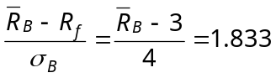
or

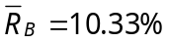

So, for the ranking to be reversed, Fund B’s average return would have to be lower than 10.33%.

